**International Calendar widget**

**Manual Installation**

1. Copy **com.temenos.widgets.internationalCalendar** folder in your widgets folder (Ex: /{your project/templates/widgets/ }). Do not overwrite the **widgets.xml** from {**your project**} folder with the one provided in the widget folder.
2. Restart IDE.

**Auto-Installation**

1. Run IDE.
2. Go into the **Tools menu** -> **Options**, **Auto-install** tab and set the **Download Location** to the folder where you want to copy the widget.
3. Make sure the “**Switch Monitor on/off**” is checked.
4. Download/ Copy the widget (**com.temenos.widgets.internationalCalendar.zip**) to monitored folder (make sure to remove the **sample** folder from the **.zip** file).

No need to restart IDE.

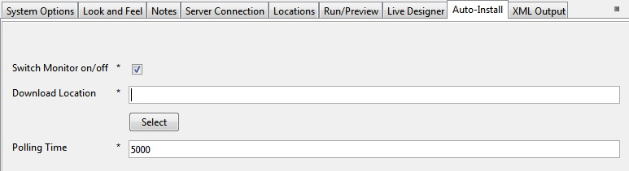

**Overview**

The **International Calendar** widget allows the user to use a calendar picker that can be setup in different languages (ex: en, fa, es, ro etc.) and calendar types (like gregorian, persian). The **International Calendar** widget will be available only for date type fields.

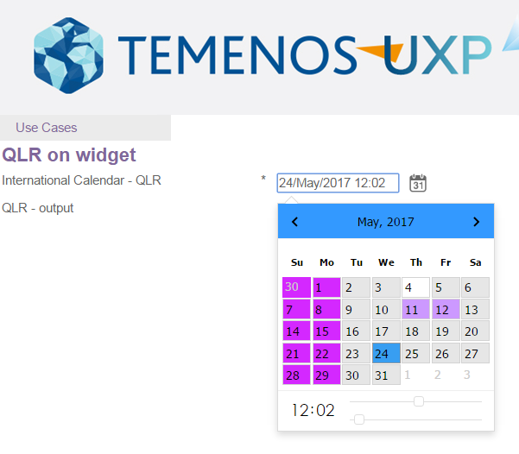

**Requirements**

For the widget to work you must have:

* EdgeConnect 6.0;
* Javascript enabled on your browser.

**Setup**

1. Create a **Data Item** in the **Data Store Editor**;

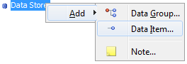

1. Give whatever name it suits your needs and select Type **Date**;

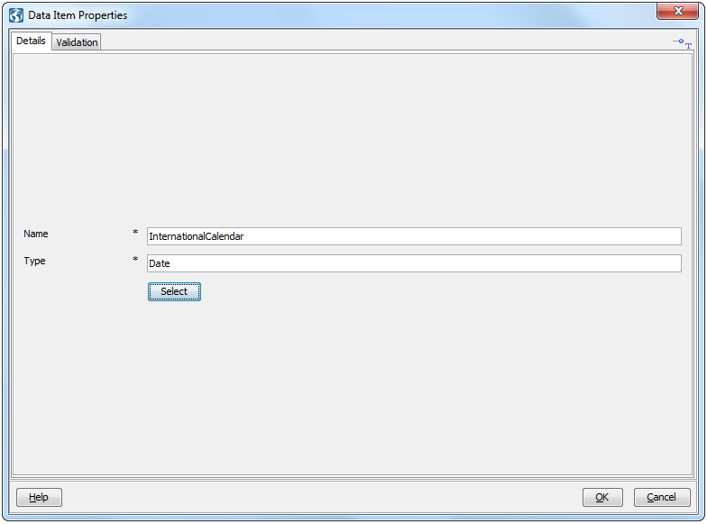

1. Create a new question in your project;

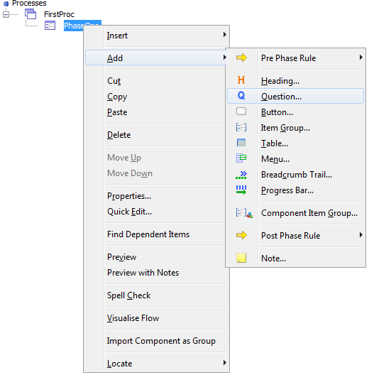

1. Go to the **Answer** tab and select the newly created **data item** from the **Data Item Chooser** window, and select ok;

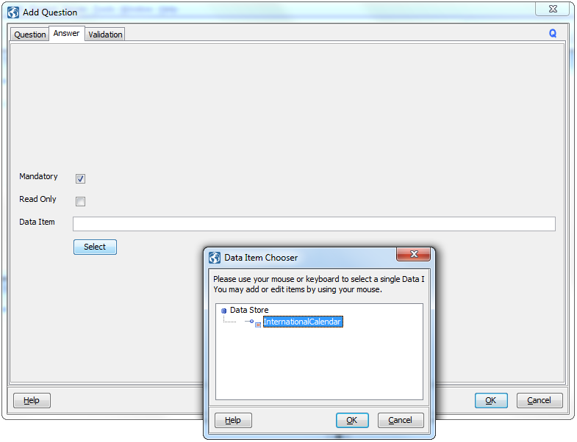

1. In the Presentation Editor, right-click on the newly created question;

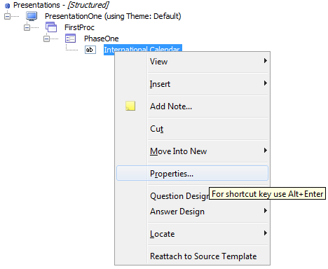

1. Go to the Answer tab and in the Display Type drop down select the InternationalCalendar widget

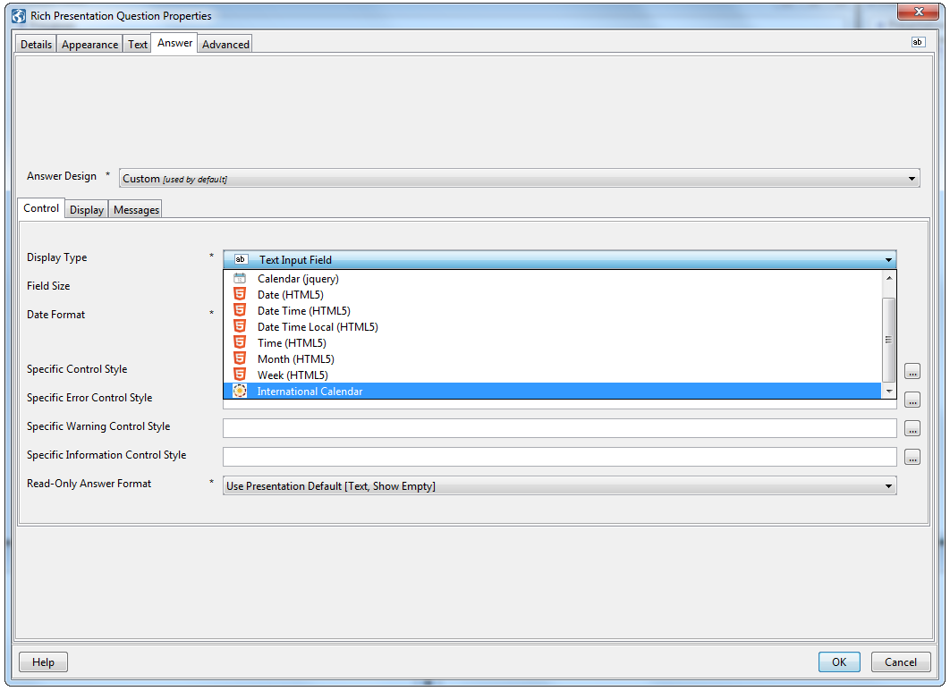

1. Go to the **Calendar Settings** tab and edit the fields as needed;

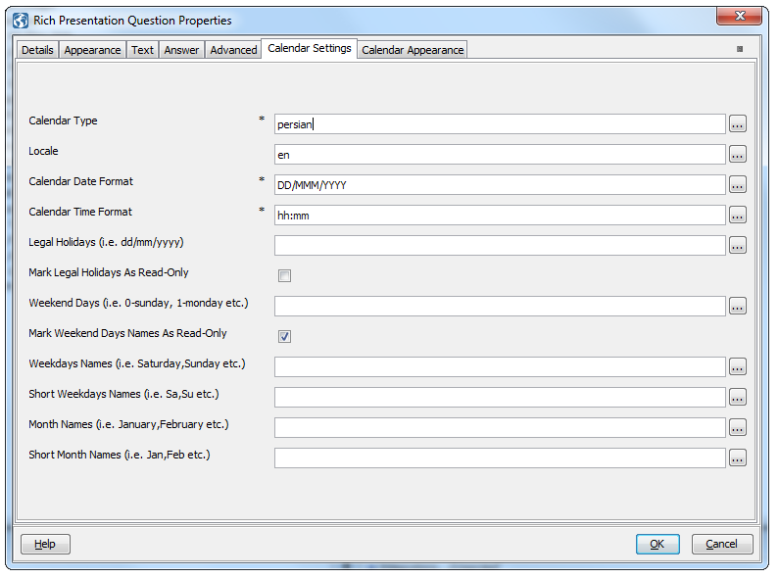

**Calendar Type** – represents the type of date generated (ex: persian, gregorian). It can be set as a list type property

**Locale** – the language used for the calendar:

**en-** - English;

**fa** - Persian;

**cs** - Czech;

**da** - Danish;

**de** - German;

**es** - Spanish;

**fi** - Finnish;

**fr** - French;

**hu** - Hungarian;

**nl** - Dutch;

**pl** - Polish;

**pt** - Portuguese;

**ro** - Romanian;

**sk** - Slovak;

**zh** - Chinese.

This are the current supported languages, if you want to create a **custom language**, you can create a new **.js** file in the **com.temenos.widgets.internationalCalendar/languages** folder using the same template as the files that resides in that folder.

**Calendar Date Format** – the format of the date that appears in the browser. Down bellow is a list of recognized formats:

|  |  |  |
| --- | --- | --- |
| **Month** | M | 1 2 … 11 12 |
|  | MM | 01 02 … 11 12 |
|  | MMM | Jan Feb … Nov Dec |
|  | MMMM | January February … November December |
| **Day of Month** | D | 1 2 … 30 31 |
|  | DD | 01 02 … 30 31 |
| **Day of Week** | ddd | Sun Mon … Fri Sat |
|  | dddd | Sunday Monday … Friday Saturday |
| **Year** | YY | 70 71 … 29 30 |
|  | YYYY | 1970 1971 … 2029 2030 |
| **Hour** | HH | 00 01 … 22 23 |
|  | h | 0 1 … 22 23 |
|  | hh | 00 01 … 22 23 |
| **Minutes** | m | 0 1 … 59 60 |
|  | mm | 00 01 … 59 60 |

We can have the following formats: DD MMM YYYY, DD/MM/YYYY, YYYY/MM/DD, MM/DD/YYYY, DD.MM.YYYY and others with the combination of letters from the table up above.

**Calendar Time Format** - the format of the time that appears in the browser;

**Legal Holidays** – holds multiple comma separated dates that respect the format dd/mm/yyyy;

**Mark legal Holidays As Read-Only** - it makes the dates inputted in the field above unselectable in the calendar picker;

**Weekend Days** – holds multiple days of the week (from 0 – Sunday to 6 – Saturday);

**Mark Weekend Days As Read-Only** – it makes the days inputted in the field above unselectable in the calendar picker;

**Week Names** – overwrites the week names. By default the name of the weeks are given by the locale attribute;

**Short Week Names** – overwrites the short week names. By default the name of the weeks are given by the locale attribute;

**Month Names** – overwrites month names. By default the name of the weeks are given by the locale attribute;

**Short Month Names** – overwrites short month names. By default the name of the weeks is given by the locale attribute.

1. Go to the Calendar Appearance tab and edit the fields as needed.

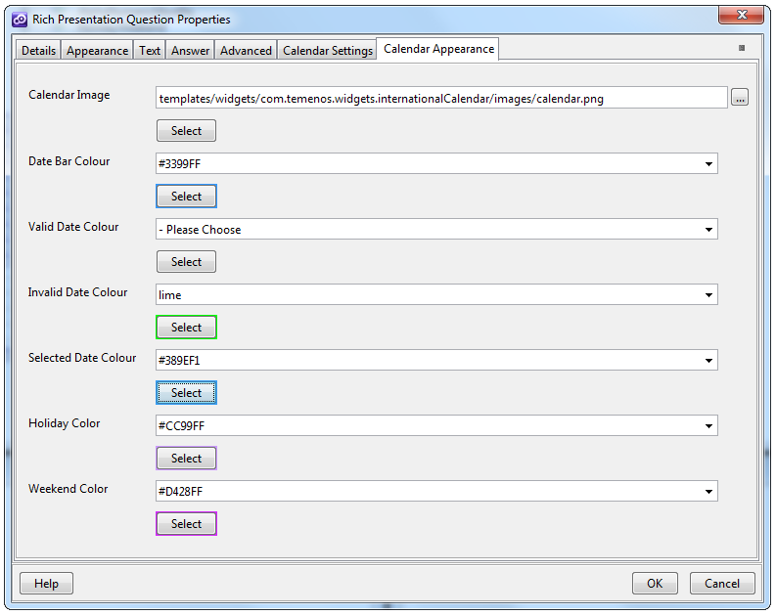

**Calendar image** – is the icon that is displayed in the calendars input field. For the calendar image to appear you have to make sure that you have the Show date chooser tick, checked in the Answer tab (Answer tab -> Control sub tab -> Edit -> Show date chooser) ;



**Date Bar Colour** – background color for the International **Calendar Datepicker** navigation bar;

**Valid Date Colour** – background color for the date that is selectable;

**Invalid Date Colour** – background color for the invalid dates;

**Selected Date Colour** – background color for the selected date.

1. Back into the Answer tab we have a few more options with we can use (please select in the **Date Format Type** field – **Specify date format** if you want to see the modifications in the browser):

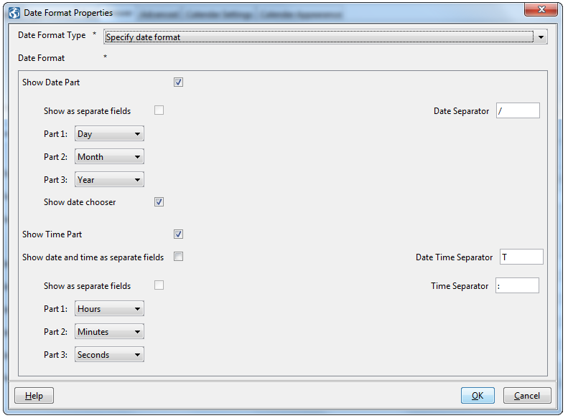

**Show date chooser** – it displays the **Calendar Image** icon in the browsers input;



**Show Time Part** – it displays the time controls in the datepicker and the widgets input;

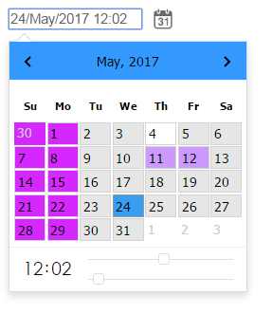

**Expected behavior**

The International Calendar widget will not work with different type (or locale) calendars in the same phase.